[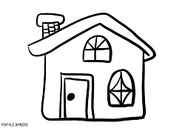](https://www.google.it/url?sa=i&rct=j&q=&esrc=s&source=images&cd=&cad=rja&uact=8&ved=2ahUKEwiA4KLI3IjgAhUCMewKHepfDigQjRx6BAgBEAU&url=https://portalebambini.it/disegni-di-case-da-colorare/&psig=AOvVaw380MHbcz8SH5oLSDVkMvO9&ust=1548498394672060) [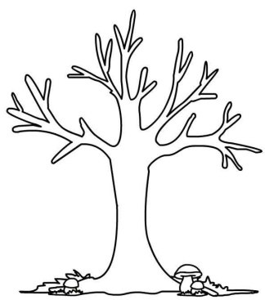](https://www.google.it/url?sa=i&rct=j&q=&esrc=s&source=images&cd=&cad=rja&uact=8&ved=2ahUKEwipo7HZ3IjgAhXPy6QKHWVwAtAQjRx6BAgBEAU&url=https://www.pinterest.com/pin/610237818231141849/&psig=AOvVaw1algFSRjmtnIWV00mq5U3i&ust=1548498523179038) [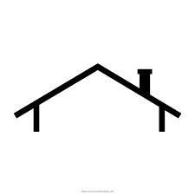](https://www.google.it/url?sa=i&rct=j&q=&esrc=s&source=images&cd=&ved=2ahUKEwiO4q2l3YjgAhXJCewKHWh8AlwQjRx6BAgBEAU&url=https://it.kisspng.com/kisspng-1a72o3/preview.html&psig=AOvVaw00I1vnFw2a4pANkwvgm2Yy&ust=1548498676983470) 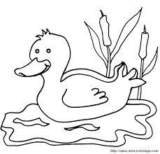

[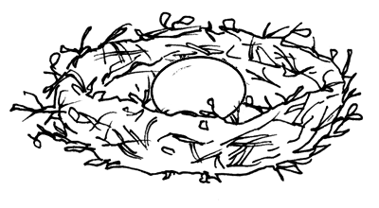](https://www.google.it/url?sa=i&rct=j&q=&esrc=s&source=images&cd=&cad=rja&uact=8&ved=2ahUKEwi0oKKC3YjgAhUGGewKHTmlC6EQjRx6BAgBEAU&url=http://www.midisegni.it/disegni/vivaio.shtml&psig=AOvVaw0J92FeB27R7BokJKWnKuMk&ust=1548498560684296) [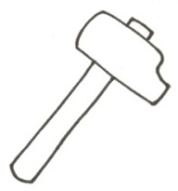](https://www.google.it/url?sa=i&rct=j&q=&esrc=s&source=images&cd=&cad=rja&uact=8&ved=2ahUKEwijvNGS3YjgAhVO-aQKHShiCXsQjRx6BAgBEAU&url=http://disegni.timmyascuola.net/ATTREZZI/index.php?showimage=martello_1.jpg&screenwidth=1024&psig=AOvVaw3_aHDHaaPRW0A5rOQz15O5&ust=1548498642486468) 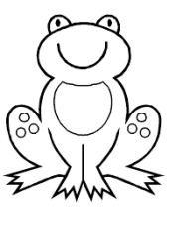 [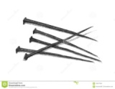](https://www.google.it/url?sa=i&rct=j&q=&esrc=s&source=images&cd=&cad=rja&uact=8&ved=2ahUKEwipkqjQ3YjgAhWK26QKHalUBEsQjRx6BAgBEAU&url=https://it.dreamstime.com/disegno-dei-chiodi-antichi-isolati-su-bianco-image123417649&psig=AOvVaw2vXd9825fKX2P9QEEM2mS2&ust=1548498718326330) 

[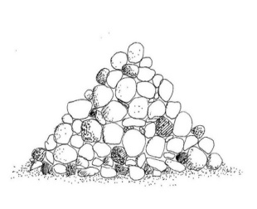](https://www.google.it/url?sa=i&rct=j&q=&esrc=s&source=images&cd=&cad=rja&uact=8&ved=2ahUKEwix3oT-3YjgAhWHyqQKHRZxBZoQjRx6BAgBEAU&url=http://www.pangea-project.org/manufatti-in-pietra/&psig=AOvVaw1c_5c8F-tZO3WPj5IOG9cZ&ust=1548498847927529) 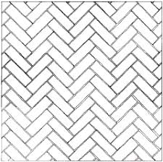 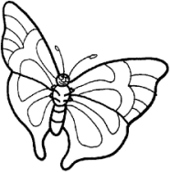 [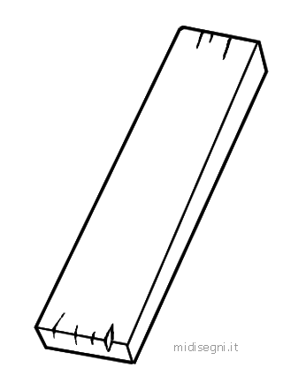](https://www.google.it/url?sa=i&rct=j&q=&esrc=s&source=images&cd=&cad=rja&uact=8&ved=2ahUKEwjGp-Pj3YjgAhVS16QKHUvDAjsQjRx6BAgBEAU&url=http://www.midisegni.it/disegni/musica.shtml&psig=AOvVaw3LIiX1BBsf5YVz7KfzcmiR&ust=1548498817666244) 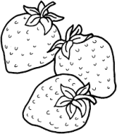

[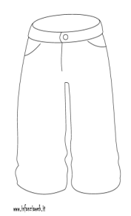](https://www.google.it/url?sa=i&rct=j&q=&esrc=s&source=images&cd=&cad=rja&uact=8&ved=2ahUKEwip8pfy3ojgAhWLMewKHQmSBrUQjRx6BAgBEAU&url=http://www.infanziaweb.it/disegnidacolorare/disegni/abbigliamento/pantaloni-1596.html&psig=AOvVaw0sdMDFIEZX4Uoxe0fxwADp&ust=1548499113497681) [](https://www.google.it/url?sa=i&rct=j&q=&esrc=s&source=images&cd=&cad=rja&uact=8&ved=2ahUKEwiWmOqK3ojgAhXHDuwKHcBRAvEQjRx6BAgBEAU&url=https://it.123rf.com/archivio-fotografico/vento_cartoon.html&psig=AOvVaw2mQx9BrxHutNo_Dx7oucxn&ust=1548498902264210)  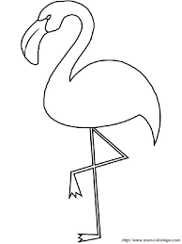

[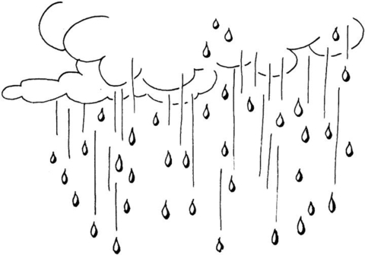](https://www.google.it/url?sa=i&rct=j&q=&esrc=s&source=images&cd=&cad=rja&uact=8&ved=2ahUKEwiCwd2V3ojgAhVK_aQKHfoXDggQjRx6BAgBEAU&url=http://www.supercoloring.com/it/disegni-da-colorare/pioggia&psig=AOvVaw25d1KfTx85981oXS27a1la&ust=1548498925065425) [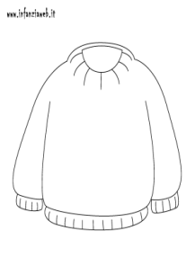](https://www.google.it/url?sa=i&rct=j&q=&esrc=s&source=images&cd=&ved=2ahUKEwjKpdDa3ojgAhVLNOwKHX5UDiUQjRx6BAgBEAU&url=http://www.infanziaweb.it/disegnidacolorare/disegni/abbigliamento/maglione-1594.html&psig=AOvVaw16EL_Rb3CVKtlUypzgofEc&ust=1548499065704712) 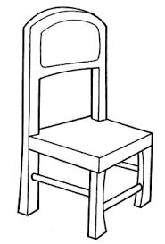 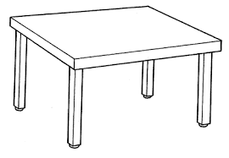 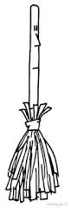

WIND BROOM CHAIR STRAWBERRIES JUMPER RAIN FLAMINGO HAT TROUSERS FLOOR BUTTERFLY NEST TABLE HAMMER FROG NAILS MIRROR DUCK ROOF TREE HOUSE STONES